**Makalah Vania Framework**

**API GET, POST, PUT, DELETE**

Makalah ini berisi dokumentasi dari kode program dari Vania framework Bahasa pemrograman dart untuk membuat API dengan method GET, POST, PUT, DELETE menggunakan database MySql dengan database design sebagai berikut :

1. **Database design**

1. **Kode program beserta Output Postman**

Link github kode program : https://github.com/esaage/vania_api

1. Customers

* GET

kode program :

Hasil postman :

* POST

Kode program :

Hasil postman :

* PUT

Kode program :

Hasil postman :

* DELETE

Kode program :

Hasil postman :

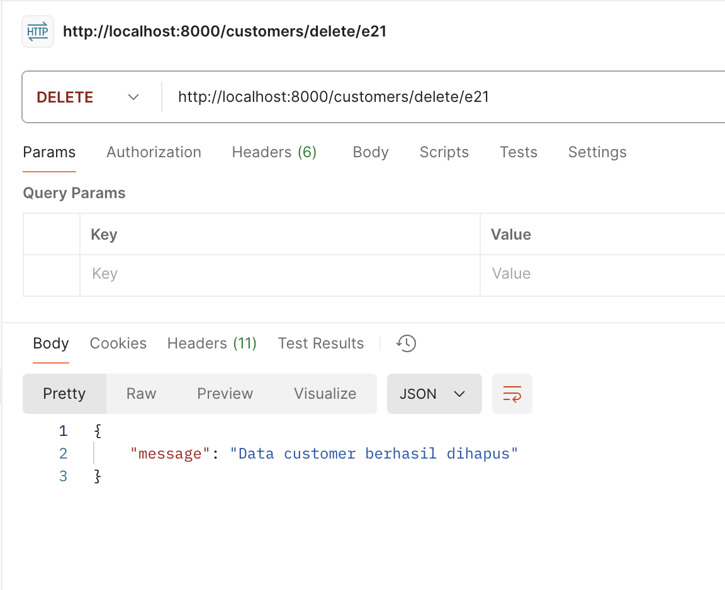

1. Orders

* GET

Kode program :

Hasil postman :

* POST

Kode program :

Hasil postman :

* PUT

Kode program :

Hasil postman :

* DELETE

Kode program :

Hasil postman :

1. Orders item

* GET

Kode program :

Hasil postman :

* POST

Kode program :

Hasil postman :

* PUT

Kode program :

Hasil postman :

* DELETE

Kode program :

Hasil postman :

1. Vendors

* GET

Kode program :

Hasil postman :

* POST

Kode program :

Hasil postman :

* PUT

Kode program :

Hasil postman :

* DELETE

Kode program :

Hasil postman :

1. Products

* GET

Kode program :

Hasil postman :

* POST

Kode program :

Hasil postman :

* PUT

Kode program :

Hasil postman :

* DELETE

Kode program :

Hasil postman :

1. Products notes

* GET

Kode program :

Hasil postman :

* POST

Kode program :

Hasil postman :

* PUT

Kode program :

Hasil postman :

* DELETE

Hasil postman :

